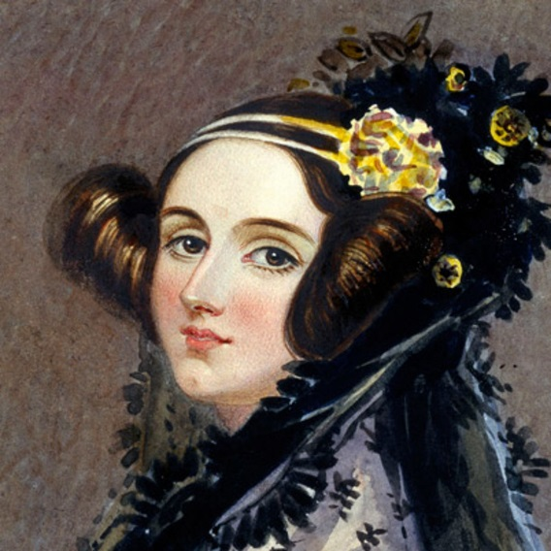
Ada Lovelace
- born in London on December 10, 1815
- died on November 27, 1852.
- Ada showed her gift for mathematics at an early age. She translated an article on an invention by Charles Babbage, and added her own comments
- Because she introduced many computer concepts, Ada is considered the first computer programmer.
- Ada had an unusual upbringing for an aristocratic girl in the mid-1800s. At her mother's insistence, tutors taught her mathematics and science. Such challenging subjects were not standard fare for women at the time.
- It was mathematics that gave her life its wings.
- Charles Babbage, a professor of mathematics at Cambridge, was known as the inventor of the Difference Engine, an elaborate calculating machine that operated by the method of finite differences. Ada met Babbage in 1833, when she was just 17, and they began a correspondence on the topics of mathematics, logic, and ultimately all subjects.
- Babbage had an idea for another new mathematical device called the analytical Engine, but his sponsors did not want to hear about it because his first idea was not finished yet. He and Ada discussed this new device and later on in life Ada was asked to translate his work, which she did along with adding twice as much of her own notes and thoughts.
- Her Notes anticipate future developments, including computer-generated music. These notes were later published.
- Ada died from cancer in London on November 27, 1852
Video
https://www.youtube.com/watch?v=uBbVbqRvqTM
or
https://www.youtube.com/watch?v=xiZozgCLHc4

Sources:
http://www.biography.com/people/ada-lovelace-20825323#babbage-and-the-analytical-engine
https://www.sdsc.edu/ScienceWomen/lovelace.html

