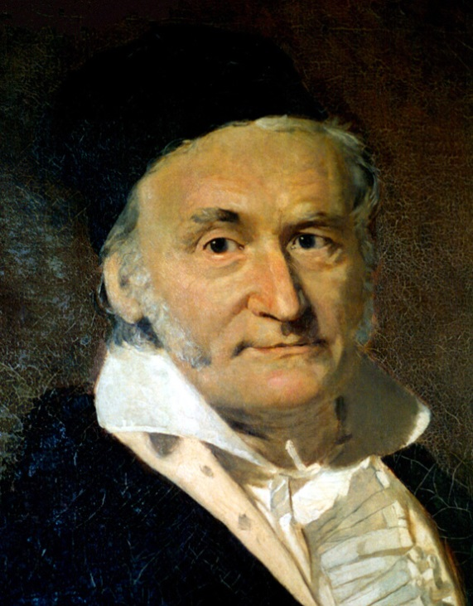
Carl Friedrich Gauss
1777-1855

- Gauss was born in Brunswick, Germany, on April 30, 1777
- Considered to be the greatest German mathematician of the nineteenth century
- His discoveries and writings influenced and left a lasting mark in the areas of number theory, astronomy, geodesy, and physics, particularly the study of electromagnetism.
- He found that a regular polygon with 17 sides could be drawn using just a compass and straight edge
- He submitted a proof that every algebraic equation has at least one root or solution. This theorem had challenged mathematicians for centuries and is called "the fundamental theorem of algebra".

https://www.youtube.com/watch?v=Prc7h8lyDXg video of Carl Guass school math add 1-100

