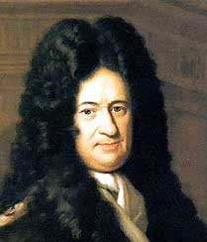
Gottfried Leibniz
Born: 1646 in Leipzig Germany
Died: Nov. 14, 1716 in Hanover (He was 70 yrs. old)

- Leibniz was a childhood prodigy. He became fluent in Latin and studied works of Greek scholars when he was only twelve. He entered the University of Leipzig when he was fourteen, where he took philosophy, mathematics and law.
- Gottfried was a prominent German mathematician, philosopher, physicist and statesman.
- Noted for his independent invention of the differential and integral calculus, Gottfried Leibniz remains one of the greatest and most influential metaphysicians, thinkers and logicians in history
- He also invented the Leibniz wheel and suggested important theories about force, energy and time.
- He made important contributions to philosophy, engineering, physics, law, politics, philology and theology.
- His greatest achievement was the discovery of a new mathematical method called calculus.
  - There was a harsh debate about whether Newton or Gottfried was the first to come up with this math. Because Newton had devised a similar method for his work on gravity.
  - Newton began working on his version in 1665, but Leibniz published his results in 1684, almost three years before Newton. However, the consensus is that they discovered the method simultaneously
- FUN FACT!!! Leibeniz has a cookie named after him ( the manufacturer of the cookie is out of Germany) The fig newton on the other hand is named after a city in Massachusetts.
- Leibniz also discovered the binary number system and invented the first calculating machine that could add, subtract, multiply and divide.
Information collected from: http://www.businessinsider.com/important-mathematicians-modern-world-2012-7

VIDEO::: https://www.youtube.com/watch?v=68bQ3qSl6jc

