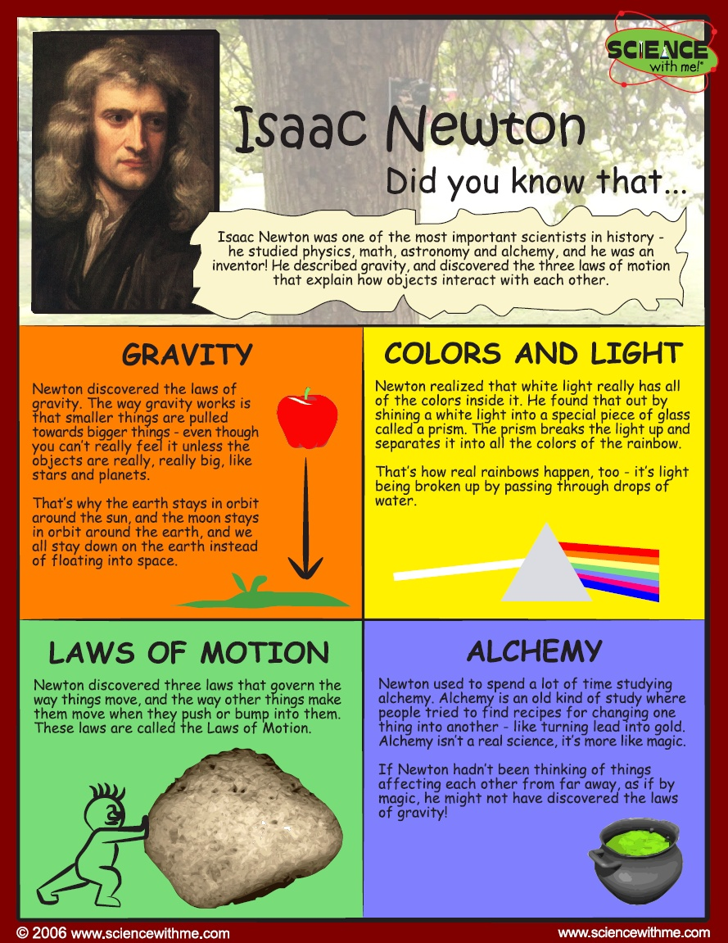
http://www.history.com/topics/enlightenment/videos/isaac-newton-and-a-scientific-revolution

