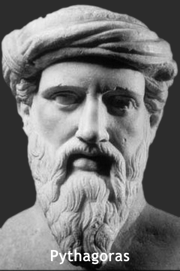
- Born: 570 BC on the Island of Samos; Died: 495 BC

- He was also a philosopher who taught that numbers were the essence of all things. He associated numbers with virtues, colors, music and other qualities.

- He believed that the human soul is immortal and after death it moves into another living being, sometimes an animal.

- Pythagoras was a Greek mathematician known for formulating the Pythagorean Theorem.

- The principles of the Pythagorean Theorem had already been known before they were formulated by Pythagoras. The Egyptians used a form of the Pythagorean Theorem to lay out their fields and the Greeks borrowed it from the Egyptians. The theorem says that in a right triangle, the square of the hypotenuse equals the sum of the squares of the other two sides. A right triangle is a triangle where one angle equals 90 degrees and the hypotenuse is the side opposite the right angle. If you know the values of two sides of a right triangle, you can easily calculate the missing side.

- Pythagoras also developed a method of tuning instruments called the Pythagorean tuning.

- Pythagoras taught his teachings through word of mouth, no written documents by Pythagoras have been found.

- TODAY
Pythagorean Theorem has many uses today.
- It is used to find missing lengths and heights of buildings using shadow ratios.
- It is used in construction to find missing sides and lengths (to eliminate the guess and check method)
- Artists use the triangle as pieces in a mosaic
- Pythagorean theorem is the basis of trigonometry
- It connects algebra and geometry
- Pythagorean’s theorem is linked to fractal geometry
- Triangulation helps today to locate cell phones making an emergency call.
- Some video games environments are drawn in 3-D using all triangles.

