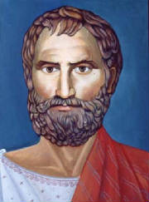
THALES
Born: c. 624 BC in Miletus, Turkey
Died: c. 547 BC (at about age 77), Location unknown
Nationality: Greek
Famous For: Formulated the five theorems of geometry

- He is considered the true father of Greek math, science, and even philosophy
- His mathematical discoveries consisted of; deductive mathematics which helped shaped theories of logic and math. The revolutionary concept called Thales Theorem which noted there are three points in a circle: A, B, and C. The diameter would be the line between points A and C.
- Thales is known to have discovered that a circle can be bisected by its diameter and that in an isosceles triangle, the base angles are equal.
- Thales believed that the Earth was a disc shape, not a sphere, and that the ocean was infinite. These were proved wrong thousands of years after Thales had noted his theory.

https://www.youtube.com/watch?v=YHboJiVmYWE

