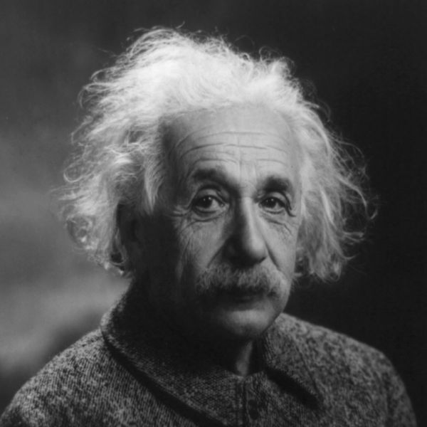
ALBERT EINSTEIN
- Born 1879 in Germany
Died 1955 at 76 years old

- He was best known for theory of relativity
Albert's famous formula was "E=mc2". This formula states that matter can be converted into energy. In this mathematical equation, E stands for energy, m for mass and c for the speed of the light in a vacuum (ca. 300,000 km/s).

- Rumor had it that Einstein failed at math, when Einstein heard the rumor he reportedly found the article humorous and remarked: ““I never failed in mathematics… Before I was fifteen I had mastered differential and integral calculus.”

- By the age of 12, Einstein took it upon himself learn geometry and algebra on his own. In one summer, he mastered both subjects, while coming up with his own proofs to prove the various mathematical theories he was studying, including his own way to prove the Pythagorean Theorem. He also began learning calculus, which was about three years ahead of his classmates.

- Einstein's great breakthroughs came from visual experiments performed in his head rather than the lab.

- Einstein was famous for having bad memory. He could not remember names, dates and phone numbers.

http://www.biography.com/people/albert-einstein-9285408#synopsis

