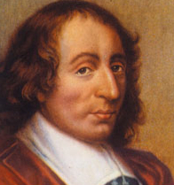
BLAISE PASCAL
- Born June 19, 1623, France, died August 19, 1662, Paris.

- Étienne (Blaises Father) was an accomplished mathematician who refused to allow Blaise to study mathematics. This was because he, being a mathematician himself, felt that it would take away from his other studies since math was such a fulfilling subject and it “fills and greatly satisfies the mind.”

- At the young age of twelve, he was drawing geometric figures on the floor of his playroom and it is said that he discovered, on his own, the fact that the interior angles of a triangle add up to the sum of two right angles. His proud father who witnessed this act presented Blaise with a copy of Euclid's Elements and from this time on allowed him to continue his studies in mathematics.

- He laid the foundation for the modern theory of probabilities, formulated what came to be known as Pascal’s law of pressure.

- He worked on conic sections and produced important theorems in projective geometry.

- Invented the very first idea of a calculating device. This was his main claim to fame.

http://study.com/academy/lesson/blaise-pascal-contributions-inventions-facts.html partial video

Pascals Triangle http://www.mathsisfun.com/pascals-triangle.html

