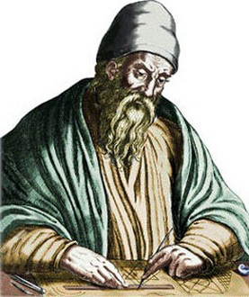
EUCLID
The father of geometry
Born 300 bc, Alexandria, Egypt
- Euclid's great work consisted of thirteen books covering a vast body of mathematical knowledge, spanning arithmetic, geometry and number theory.

- He was the first to prove that there are infinitely many prime numbers.

- The Elements introduced the notions of axiom and theorem; was used as a textbook for 2000 years, and in fact is still the basis for high school geometry

- Abraham Lincoln carried a copy of Euclids book Elements with him and studied it in order to become a better lawyer.

- "Euclid" is a Greek word, meaning "Good Glory".

- Although several of the results in Elements began with prior mathematicians, one of Euclid's achievements was to present them in a single, logically comprehensible framework, making it simple to use and easy to mention.

https://www.youtube.com/watch?v=Mc0bvea6G3I
https://www.youtube.com/watch?v=_KUGLOiZyK8
https://www.youtube.com/watch?v=U-ANBNn_D_A

