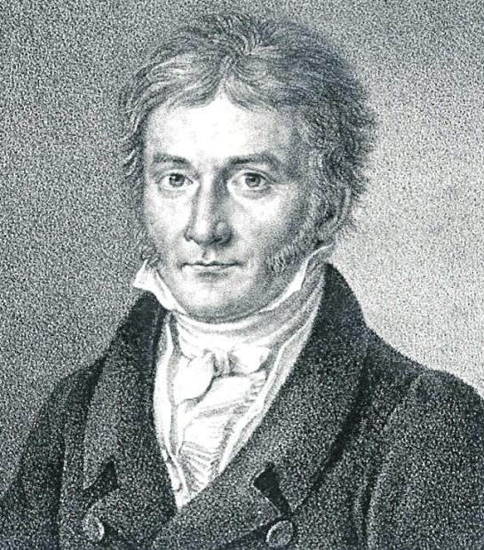
Johann Carl Friedrich Gauss
(1777-1855) Germany
- Known as the "Prince of Mathematics"
- exhibited his calculative powers when he corrected his father's arithmetic before the age of three
- Gauss may be the greatest theorem prover ever.
  - He was first to produce a complete proof of Euclid's Fundamental Theorem of Arithmetic (that every natural number has a unique expression as product of primes); and first to produce a rigorous proof of the Fundamental Theorem of Algebra (that an n-th degree polynomial has n complex roots). Gauss was first to provide a proof for this, and provided eight distinct proofs for it over the years. Gauss proved the n=3 case of Fermat's Last Theorem for a class of complex integers.
- Gauss developed the arithmetic of congruences and became the premier number theoretician of all time.
- Other contributions of Gauss include hypergeometric series, foundations of statistics, and differential geometry. He proved a surprising fundamental theorem about the curvature of manifolds. He also did important work in geometry

