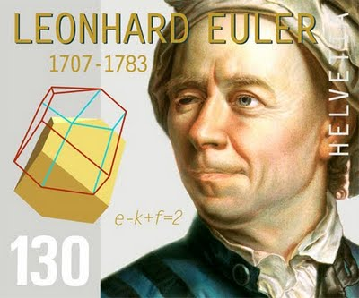
Leonhard Euler
- Born on April 15, 1707, in Basel, Switzerland

- Died on September 18, 1783.

- Moved to Russia in 1727, Euler served in the navy before joining the St. Petersburg Academy as a professor of physics and later heading its mathematics division.

- He was a revolutionary thinker in the fields of geometry, trigonometry, calculus, differential equations, number theory and notational systems—including the utilization of π and f(x)—among a legion of other accomplishments.

- His Euler's Identity theorem is often cited as the most delightful of equations and his work also focused on the fields of astronomy/lunar motion, acoustics, mechanics and music.

- Having suffered from fevers and overexertion due to cartography work, Euler was severely hampered in the ability to see from his right eye. By the early 1770s, Euler had lost his sight completely after not allowing for proper recuperation after an operation

- He released hundreds of articles and publications during his lifetime, and continued to publish after losing his sight.

Video
- https://www.youtube.com/watch?v=Ty6ejK1rAkg

Sources:
http://www.biography.com/people/leonhard-euler-21342391#death-and-legacy

