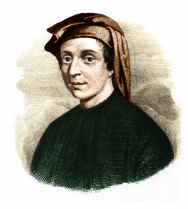Leonardo Pisano Fibonacci

* an Italian number theorist
* It is believed that Leonardo Pisano Fibonacci was born in the 13th century, in 1170 (approximately) and that he died in 1250
* Fibonacci was born in Italy but obtained his education in North Africa
* Much of the information about Fibonacci has been gathered by his autobiographical notes which he included in his books.
* Fibonacci gave us our decimal number system (Hindu-Arabic numbering system, using number 0-9) which replaced the Roman Numeral system
* The Fibonacci sequence is a pattern of numbers where each number is the sum of the two preceding numbers, starting with 0 and 1: 0, 1, 1, 2, 3, 5, 8, 13 . . .
* [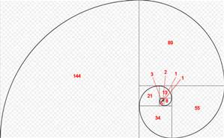](http://www.bing.com/images/search?q=fibonacci&view=detailv2&&id=E490BCDC77C07523856A501DDEB78D8E8697A9B1&selectedIndex=0&ccid=Uyp3zSgz&simid=607997796097851957&thid=OIP.M532a77cd283314300fd3bb3dd6f1d0feH0)This sequence has connections to several different mathematical and natural subjects, including the [golden ratio](https://en.wikipedia.org/wiki/Golden_ratio), the [Fibonacci spiral](https://en.wikipedia.org/wiki/Golden_spiral), and [Pascal's triangle](https://en.wikipedia.org/wiki/Pascal%27s_triangle). Because of its wide range of appearances and applications, it has become a subject of fascination and [popular culture](https://en.wikipedia.org/wiki/Fibonacci_numbers_in_popular_culture).

[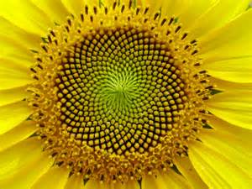](http://www.bing.com/images/search?q=fibonacci&view=detailv2&&id=4B4468CD720182D6F3C424D64C43F02FF956A58B&selectedIndex=1&ccid=HzC3IwCJ&simid=608024416297158226&thid=OIP.M1f30b7230089b25b1791986790fa0963H0)

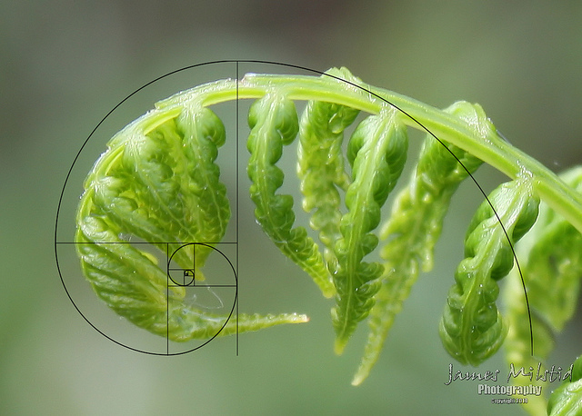[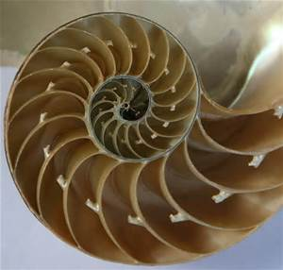](http://www.bing.com/images/search?q=fibonacci&view=detailv2&&id=DD400A16C540E8F72DF0578866F5783D136A73B7&selectedIndex=3&ccid=y/90Ar22&simid=607987067270332696&thid=OIP.Mcbff7402bdb676dcd8c7c006e06ba022H0)

Sources:

<http://math.about.com/od/mathematicians/a/fibonacci.htm>

<http://www-history.mcs.st-and.ac.uk/Biographies/Fibonacci.html>

Video

<http://www.bing.com/videos/search?q=leonardo+fibonacci+biography&&view=detail&mid=726D50F3C7FBE169D6A1726D50F3C7FBE169D6A1&FORM=VRDGAR> ( scientist enthusiastically explains sequence)

<https://www.youtube.com/watch?v=o5pmU21smjU> (history of sequence) Cut off at break



<https://www.youtube.com/watch?v=kkGeOWYOFoA#t=209> (video of pics with fibonoccie sequence)