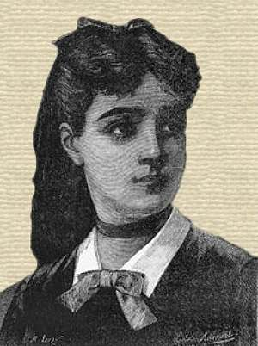
Marie Sophie Germain

- Born, April 1, 1776, in Paris France
- Died, June 27, 1831
- French philosopher, physicist, and mathematician.
- Her parents were not okay with the idea that their daughter loved mathematics; they tried to stop her. But eventually, they realized their daughter was serious.
- Due to prejudice against her gender, Germain was never able to make a career out of mathematics.
- She became the first woman to win a prize from the Paris Academy of Sciences, for a paper she wrote on elasticity.
- The very public prizewinning gained her some attention. But her gender kept her "always on the outside, like a foreigner, at a distance from the professional scientific culture.”
- In 1831, she published her paper on the curvature of elastic surfaces. She also published principles of examination that later led to the discovery of laws of equilibrium and the movement of elastic solids.
- In her work on number theory, Sophie Germain made partial progress on a proof of Fermat's Last Theorem. For prime exponents less than 100, she showed there could be no solutions relatively prime to the exponent.
- A school in Paris -- L'École Sophie Germain -- and a street -- la rue Germain -- honor her memory in Paris today. Certain prime numbers are called "Sophie Germain primes."
- A prime said to be a Sophie Germain prime if both and are prime. The first few Sophie Germain primes are 2, 3, 5, 11, 23, 29, 41, 53, 83, 89, 113, 131, ... (OEIS A005384). It is not known if there are an infinite number of Sophie Germain primes (Hoffman 1998, p. 190).

http://www.sdsc.edu/ScienceWomen/germain.html
http://famous-mathematicians.org/sophie-germain/
http://womenshistory.about.com/od/sciencemath1/a/sophie_germain.htm

notes video: http://www.bing.com/videos/search?q=Sophie+Germain+YouTube&&view=detail&mid=39B337610AD80259673D39B337610AD80259673D&FORM=VRDGAR

https://www.youtube.com/watch?v=5k5TYUj4jn8

