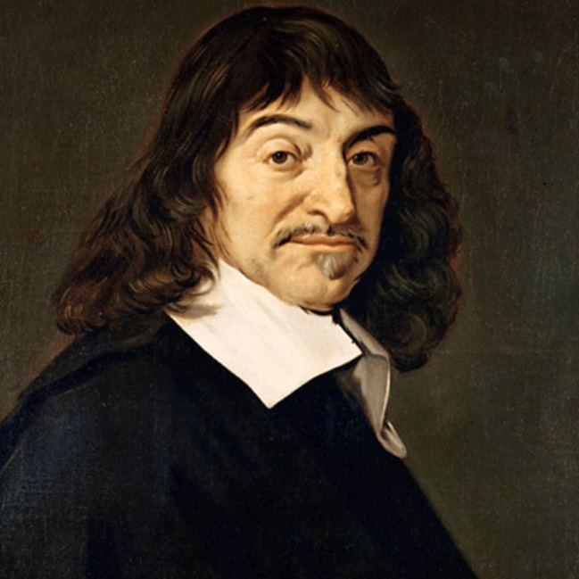
René Descartes
- Philosopher and mathematician René Descartes is regarded as the father of modern philosophy for defining a starting point for existence, “I think; therefore I am.”
- René Descartes was born on March 31, 1596, in La Haye, France
- He was extensively educated, first at a Jesuit college at age 8, then earning a law degree at 22.
- He studied subjects, such as rhetoric and logic and the “mathematical arts,” which included music and astronomy, as well as metaphysics, natural philosophy and ethics, equipped him well for his future as a philosopher.
- Since Descartes believed that all truths were ultimately linked, he sought to uncover the meaning of the natural world with a rational approach, through science and mathematics.
- He introduced Cartesian geometry, which incorporates algebra; through his laws of refraction, he developed an empirical understanding of rainbows; and he proposed a naturalistic account of the formation of the solar system.
- He died in Stockholm, Sweden, on February 11, 1650.

Source: http://www.biography.com/people/ren-descartes-37613

Video: https://www.youtube.com/watch?v=x8rYEcRypYc

